**Focus on the process and deliverables for every meeting, and the sky's the limit to how productive and engaged your team can become.**

Let’s dive into the whole scrum sprint review vs sprint retrospective confusion and learn what makes both meetings uniquely useful and integral to the scrum framework.

**What Is a Sprint Review?**

The sprint review is one of the five pivotal [scrum ceremonies.](https://geekbot.com/blog/scrum-ceremonies-and-artifacts-what-wasnt-in-the-scrum-guide/)It is held at the end of each scrum sprint. During the sprint review, the **scrum development team**, **product owner**, and **business stakeholders**gather together to discuss the sprint results.

Some scrum teams mistakenly label the sprint review meetings as a “demo” or “show and tell” meeting where they demonstrate and list out what was achieved during the sprint, but demonstration is just one aspect to this Agile ceremony.

The whole meeting is timeboxed to last from one to four hours, depending on how long your sprints are. For example, if you are using one-week sprints, the meeting should last no longer than one hour, and if you’re using sprints that last a month, the sprint review should last no more than four hours.

**The sprint review consists of three equally important parts:**

# Sprint 0 (Mon. 6th Feb - Fri. 18 Feb):

**Tasks Completed**

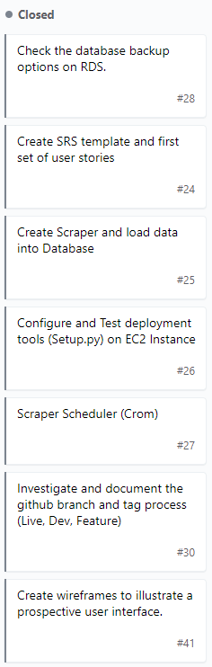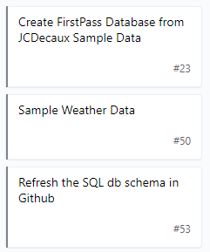

**Demonstration**

Collaboration Tools:

* GitHub
* Google Drive
* Goodday.work
* AWS (EC2 and RDS)
* Conda Environment

Data Loader

Installed on EC2, connecting to RDS, loading data and storing it in the db. But not running live.

**Discussion With Product Owner**

Expectations: Product owner expects the data loader live and running by Sunday - discussed at last meeting on Thursday.  Perhaps not finished but up and running.

## Progress overview

1) We explain to Mandy what we’ve done and why so she knows why we made certain decisions

2) Mandy explains to us what we’ve implemented and why it’s cool - to help us move forward.

**Product Backlog Update**

All completed tasks removed

Weather Data not included.

Flask install, base map, station display on the map with basic details